ECO-HOME

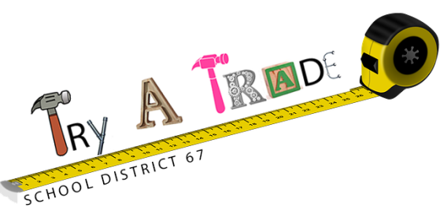Created by Brian Allanson

LETS BEGIN!
These are questions you might ask yourself as you build your ECO-HOME.

WHAT ARE THE TRADES?

WHO CAN BE A SKILLED TRADES PERSON?

WHERE CAN I GO FIND OUT ABOUT TRADES?

WHEN CAN I BEGIN TRAINING FOR A TRADE?

WHICH TRADE SUITS ME BEST?

SAFETY FIRST!
ALL JOBS HAVE DANGERS. WHETHER YOU ARE AT WORK OR PLAY,
SLOW DOWN AND ASSESS YOUR SURROUNDINGS.
WHILE YOU BUILD YOUR ECO-HOME BE CAREFUL WITH TOOLS!!
IF YOU ARE IN DOUBT, ASK QUESTIONS!!!!!
USE CAREERS67.CA FOR TOOL SAFETY VIDEOS.

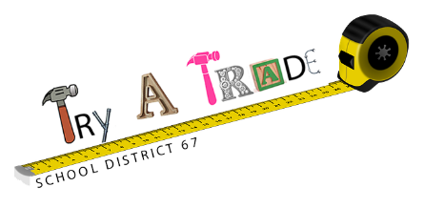LETS EXPLORE: SKILLED TRADES
GO TO: CAREERS67.CA
Under the MORE… pull down, click on TRY-A-TRADE.
Select video: CONSIDER A CAREER IN THE SKILLED TRADES.

NAME: __________________________________________________________________________
Provide some examples of SKILLED TRADES jobs:
- ___________________________________________
- ___________________________________________
- ___________________________________________
- ___________________________________________

TRUE OR FALSE? Circle your answer.
Trades people like to work with their hands TRUE FALSE
Both men and women can become a skilled trades person. TRUE FALSE
Trades people earn more money than the average Canadian house hold. TRUE FALSE
Canada will have a shortage of skilled trades people over the next 10 plus years TRUE FALSE
Skilled trades people can work anywhere in Canada. TRUE FALSE
I can begin training for a trade in highschool. TRUE FALSE

ECO-HOME

THE CHALLENGE:
It takes many trades to design and build a house. There are many components that require specialized areas of expertise. Eco-Home is a project designed to allow students and teachers to explore just a few of the necessary trades required to build a house. Although the design of this house is not necessarily 100% green or energy efficient, you are challenged to re-think what can be improved to make this project more environmentally friendly.

TRADES/AREAS TO EXPLORE:
-Carpentry -Plumbing -Green roof technology
-Electricity - Horticulture - Landscaping

SUPPLIES/TOOLS:
Each trade/area will have a corresponding tool box which will include most tools and supplies that will be required to complete each component for the ECO-HOME build. Supplies commonly found in a school environment are not included in the tool boxes.

PHASE ONE: PLANNING
Big projects always start as an idea. Houses must be carefully planned and designed to fit the needs of the people who intend to live there. Houses also have to fit into the rules of the community. There are many factors that will eventually come into play when you are in the planning and designing phase of your house. In this case you have a preset amount of space that you are allowed to use. You also must consider building codes, city by-laws, neighborhood restrictions, etc.
The following are considerations you will need to begin the planning phase:
- Property size: 28 cm x 30.5 cm.
- Setbacks: All houses are setback from the property line.
  - Interior property lines 1.0 cm
  - Exterior property lines 2.5 cm (Street side)
- House size: No bigger than 150 sq cm.
- Must include green roof. Details on green roof supplied later
- Must include garden. Approximately 10cm x 10cm.
- Driveway to street.
- Yard must have perimeter fence.
- Other(s): ASK YOUR TEACHER!!!!!
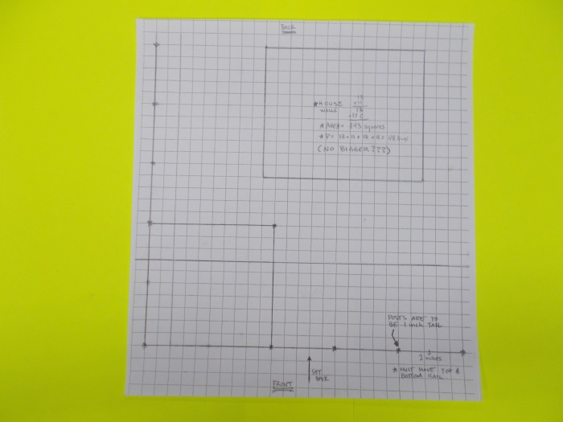
Figure 1: Laying out property with grid paper.
Your teacher will supply you with a piece of GRID PAPER. It is exactly the same size as your piece of property 30.5 cm x 28cm. Read all of the requirements on the previous page. Begin by laying out where your house will be positioned. Remember you will need a garden that is approximately 10cm x 10cm. Or approximately 100 square cm.
There is a likelihood that you will change your mind during the design/planning phase.
ALWAYS USE PENCIL!!!!
MATH IS IMPORTANT IN THE TRADES!
You will need two formulas to calculate the AREA and PERIMETER of your house.
AREA = ________________________________________________
PERIMITER = _________________________________________________________
SHOW YOUR CALCULATIONS
AREA OF MY HOUSE=__________________________________________________________

PERIMITER OF MY HOUSE=_____________________________________________________

PHASE ONE APPROVED BY MY TEACHER
TEACHER SIGNATURE

LETS EXPLORE: CARPENTRY
GO TO: CAREERS67.CA
Under the MORE… pull down, click on TRY-A-TRADE.
Select video: STARTING A CAREER AS A CARPENTER.
NAME: __________________________________________________________________________
Describe what a CARPENTER does: _____________________________________________________________________________________
_____________________________________________________________________________________
TRUE OR FALSE? Circle your answer.
Carpenters mostly work outside. TRUE FALSE
Carpenters sometimes work with both wood and concrete. TRUE FALSE
Carpenters can work in many different locations. TRUE FALSE
Circle the tools a carpenter would use.
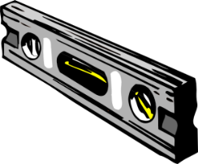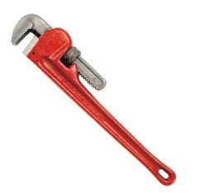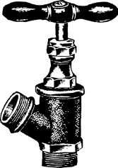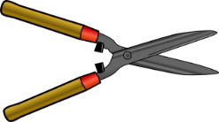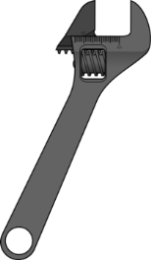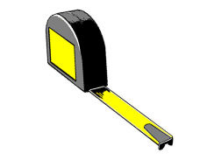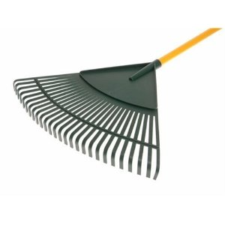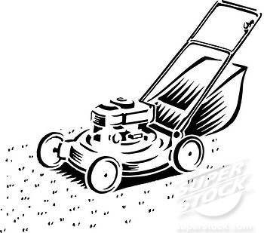
What does it take to be a Carpenter?
- Patience - Open minded
- Skilled in Math principles and Geometry - Mechanical skills use of tools
- Creative - Problem solving skills
- Attention to small details - Computer skills
PHASE TWO: HOUSE CONSTRUCTION
Traditionally, houses are constructed from materials that are readily available and easy to work with. In Canada, we have access to a renewable resource which is wood. Although construction materials are rapidly changing, in Canada we primarily use wood and concrete for residential construction.

You will need:
- Stud spacer -ruler - pencil
- Metal layout sheet - popsicle sticks - aviation snips

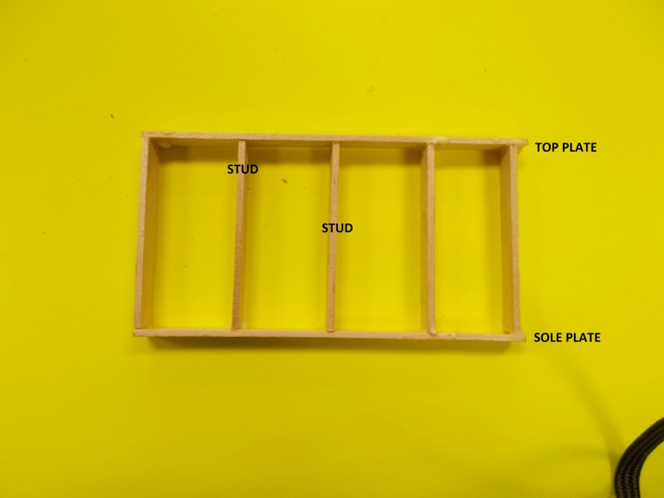
Figure 2: Wall layout.
STEP 1: Determine how many studs you will need . Using a pencil measure and mark your studs.
STEP 2: Cut your studs to length with snips.
STEP 3: Determine the lengths of your top plates and sole plates. Measure and cut them.
STEP 4: Assemble your walls.
You will need:
-stud spacer - white glue -metal assembly sheet - magnets

The following diagram will show you how to assemble and glue your walls together.
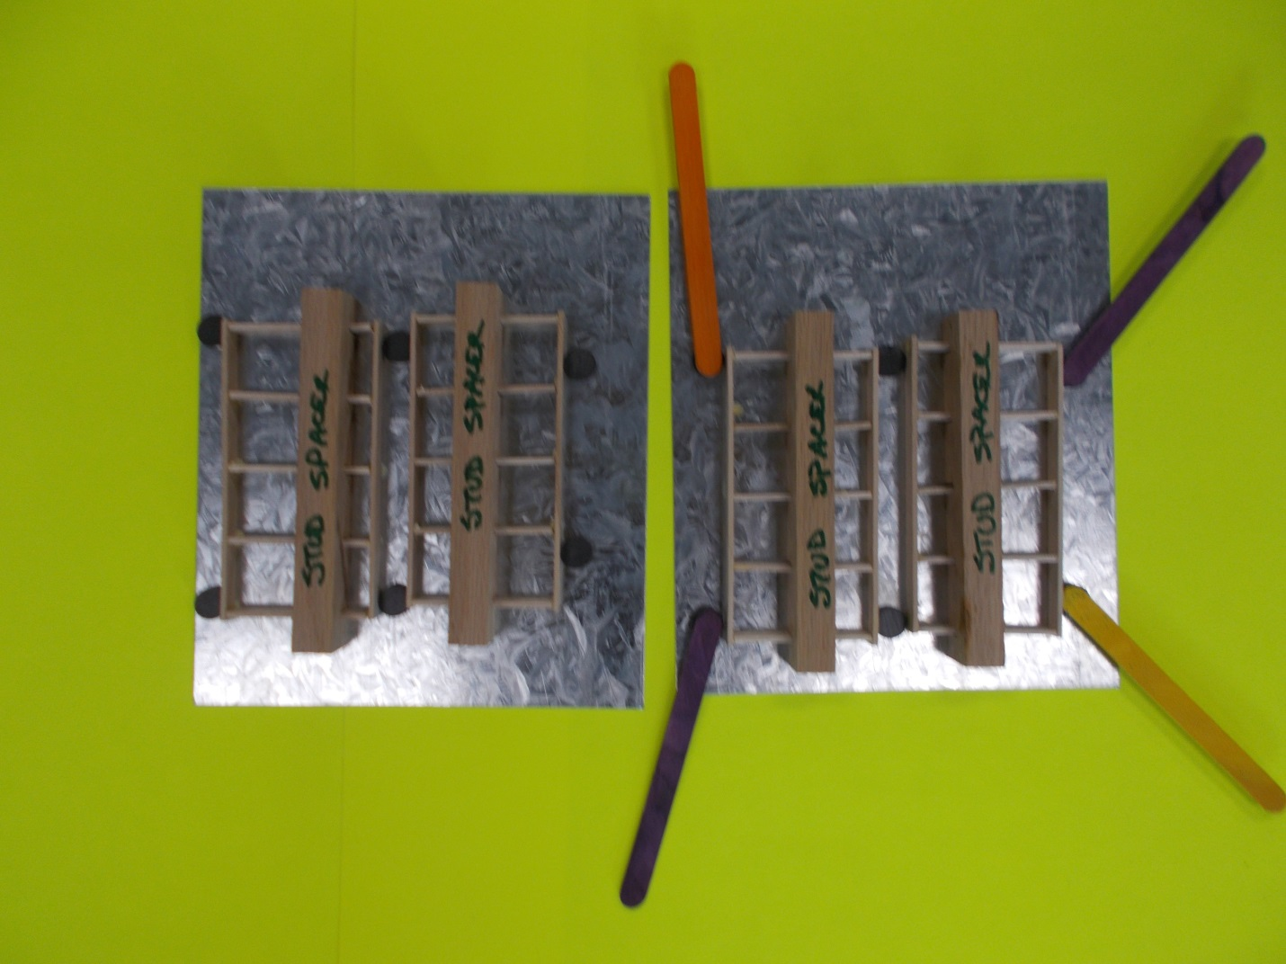
Figure 3: Using magnets and assembly plate to make walls.

STEP 5: Assemble walls together.
You will need:
- glue -metal assembly sheet - magnets - paper triangles
The following diagram shows you how to assemble walls together. Ask for help if you need an extra set of hands.
NOTE THE PAPER TRIANGLES ON CORNERS!!!! GLUE THEM ON TOP FOR ADDED STRENGTH AND STABILITY WHILE THE GLUE DRIES.
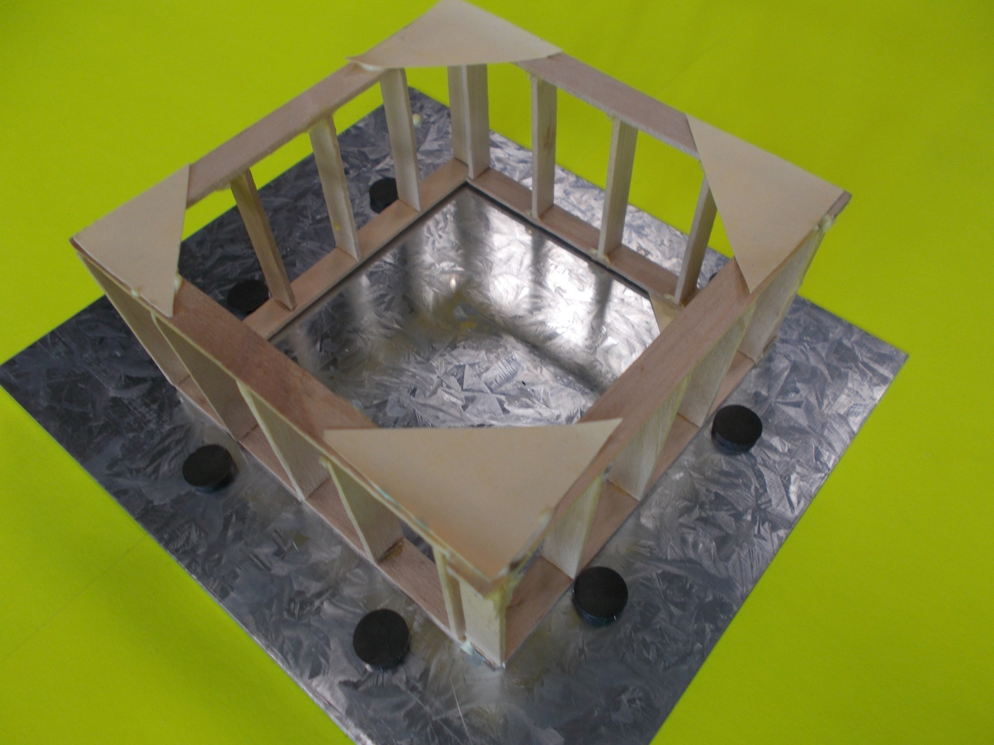
Figure 4: Using assembly plate and paper triangles to assemble walls together

HINT:
LET GLUE DRY OVER NIGHT. IT MAY WANT TO FALL APART IF YOU HANDLE IT TOO SOON.
TOO MUCH GLUE? NO WORRIES!! YOU CAN USE SCRAPER TO GET IT OFF METAL ASSEMBLY PLATE AFTER IT DRIES.
STEP 6: Adding doors –windows- siding- and detail.
You will need:
- glue -ruler -cardboard - pencil crayons - window and door example sheets

Measure each side of your house. Cut cardboard to fit each side. Once you have your sides cut, double check that each side fits. TRIM AS NECESSARY!
Now you can begin to add architectural features such as windows, doors, exterior finishes, etc.
HAVE A LOOK AT THE FOLLOWING EXAMPLES OF DOORS AND WINDOWS.
HOUSES DON’T NEED TO BE BORING!
MAKE YOUR HOUSE STAND OUT BY ADDING NICE DOORS AND WINDOWS.

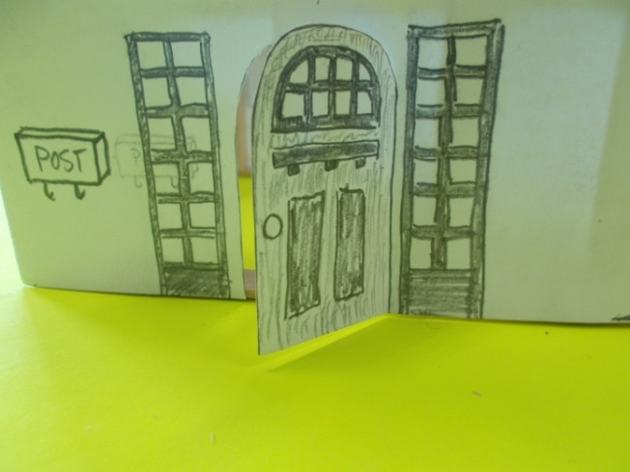
Figure 5: Adding a front door and windows.
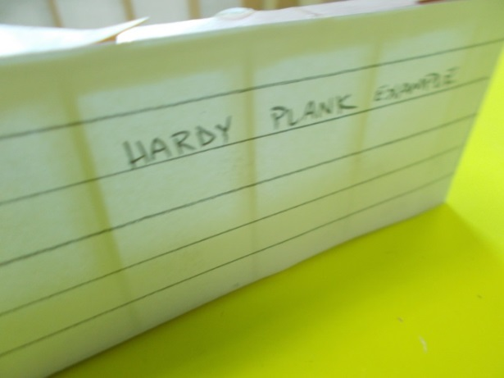
Figure 6: Example of siding that might be used.
DOORS AND WINDOWS
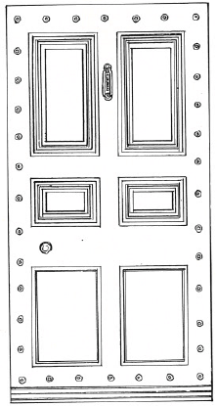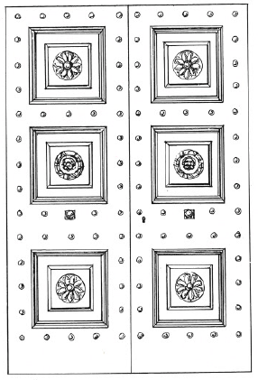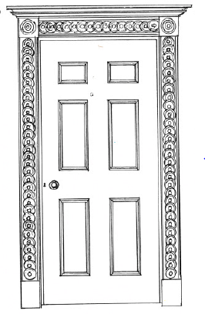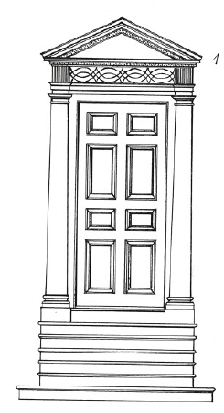

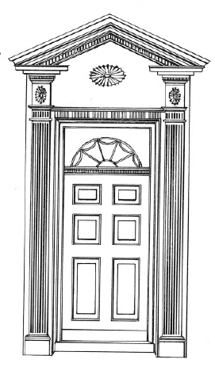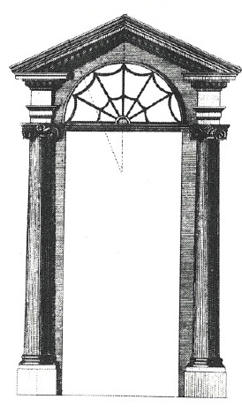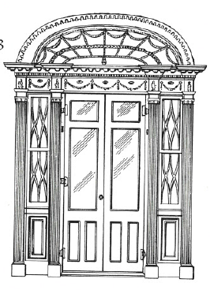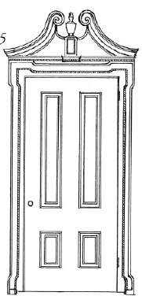

DOORS AND WINDOWS

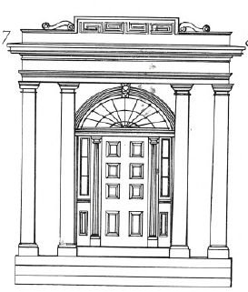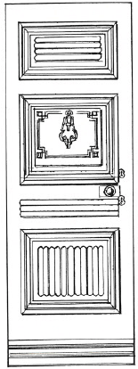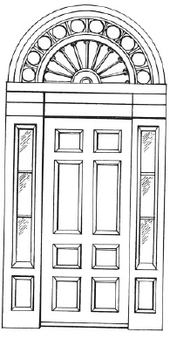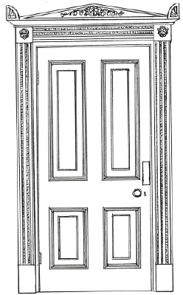

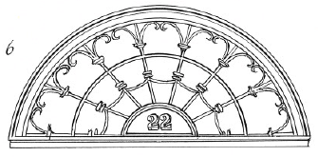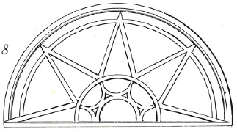

DOORS AND WINDOWS

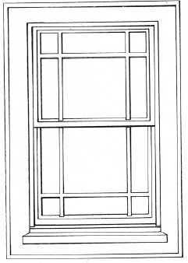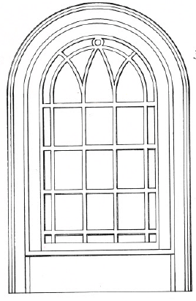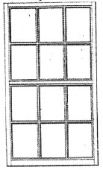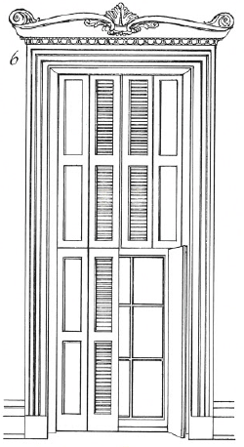

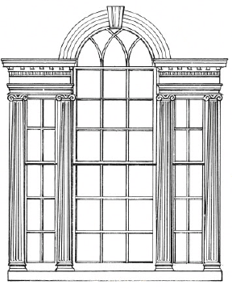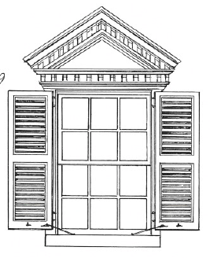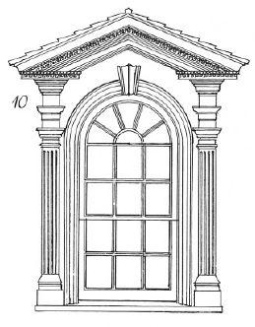

PHASE THREE: HORTICULTURE/GREEN ROOF TECHNOLOGY
WHAT IS A GREEN ROOF?
A green roof or living roof is the roof of a building that is partially or completely covered with vegetation and a growing medium. Essentially, you are growing a garden or lawn on top of a building.
WHY IS A GREEN ROOF GOOD FOR THE ENVIRONMENT?
There are many benefits to having a green roof. The following are just a few reasons why living roofs contribute to a healthy community.
- Plants generate oxygen which improves air quality in urban centers
- Plants absorb rain which helps to reduce water running through dirty streets and into the ocean.
- Green roofs absorb sound in cities.
- They can provide a green environment in an environment made of concrete.
- Provide sanctuary for necessary insects and bugs.

BUILDING A GREEN ROOF

The design of your roof is entirely up to you. Think of your roof at home. Does it have a slope? Is it flat? There are many different designs for roofs. For this build, we are using a flat roof.
You will need:
- miter box and saw -ruler -plastic coroplast - wood strips -glue

STEP ONE: MEASURE
Measure the top of your eco-home. Decide how much extra “over hang” you would like. If you are unsure, add an extra one centimeter per side.

STEP TWO: MAKE YOUR SIDES FOR ROOF
You will need to make sides for your roof so the dirt and vegetation doesn’t slide off.
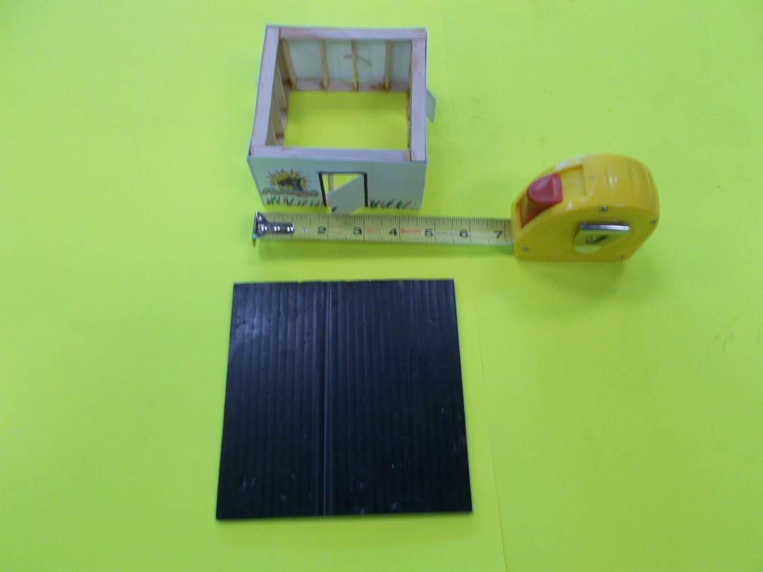
Figure 7: Designing green roof.
Measure the perimeter of your roof and cut strips of wood to fit.
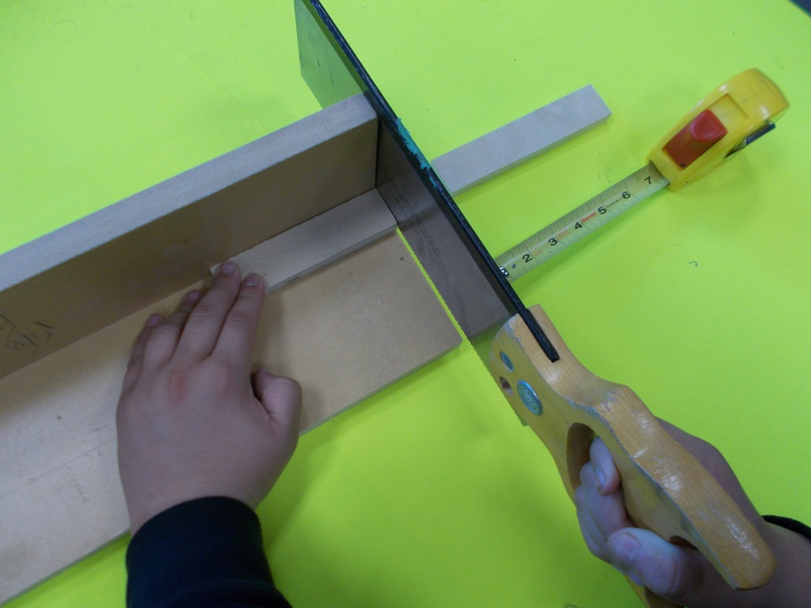
Figure 8: Cutting strips for edge of green roof.

HINT!! Always double check your measurements
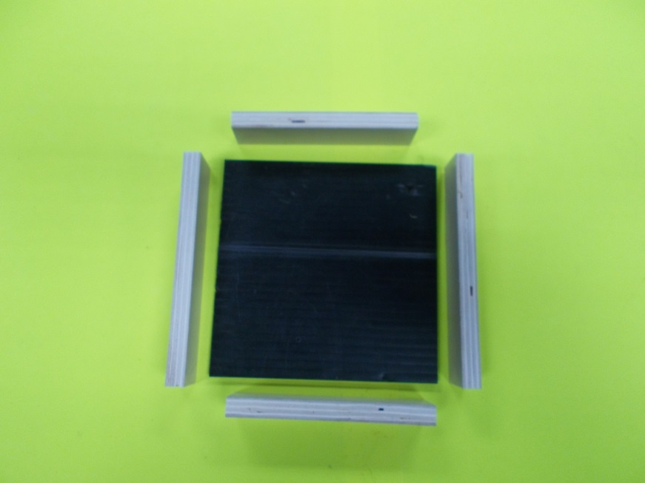
Figure 9: Edges ready to be glued to coroplast.
Glue sides onto the coroplast roof.
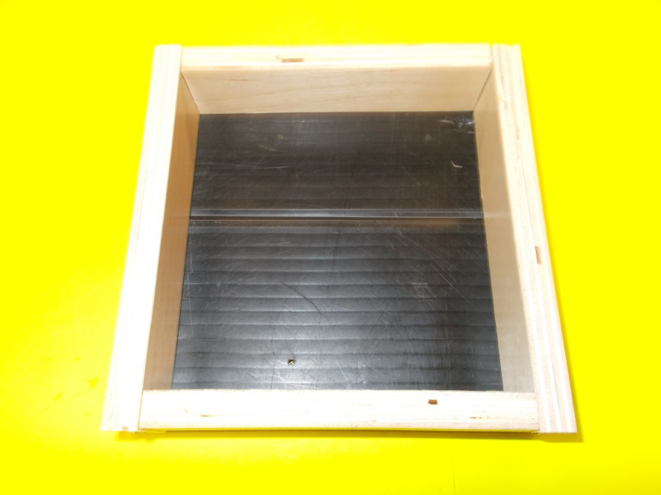
Figure 10: Sides glued to roof,

HINT: DO NOT GLUE THE ROOF ON!!!! YOU STILL NEED TO BE AN ELECTRICIAN AND WIRE YOUR HOUSE WITH LIGHT!!!!

LETS EXPLORE: HORTICULTURE/LANDSCAPING

GO TO: CAREERS67.CA
Under the MORE… pull down, click on TRY-A-TRADE.
Select video: ARBORIST APPRENTICESHIP.
NAME: __________________________________________________________________________
Describe what a HORTICULTURIST does: _____________________________________________________________________________________
_____________________________________________________________________________________
TRUE OR FALSE? Circle your answer.
Horticulturists might work on a sick tree to save it. TRUE FALSE
Horticulturists design and build gardens. TRUE FALSE
Horticulturists might work in a vineyard or winery. TRUE FALSE
Circle the tools a HORTICULTURIST would use.
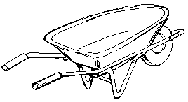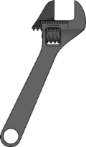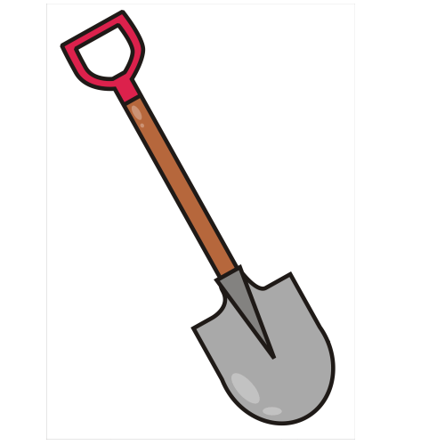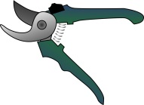
What does it take to be a Horticulturalist?
- Practical skills - Seed and plant development
- Skilled in Math principles - Grafting
- Creative - Study of plant science
- Customer service - Pruning

PHASE FOUR: LANDSCAPING
Landscaping is an integral part of house construction. It should have both form (looks good) and function (works well). Next time you drive through a neighborhood, look at the different plants, vegetation, stones, walls, trees, and driveways. There are many approaches to landscaping. Always keep in mind that some vegetation (ie. grass) must be maintained and will consume water. Instead, you might consider landscaping that is environmentally friendly.
“ZEROSCAPE” vs “XERISCAPE”
Often the terms “zeroscape” and “xeriscape” are used interchangeably. However, there are some huge differences when put to use.

Zeroscape typically refers to a mostly concrete, stone or gravel in place of a traditional landscape design. It can even mean that no landscaping has been done.

Xeriscape is a method of landscape design that minimizes the amount of additional water used by combining native plants and trees, as well as rock work, to create beautiful outdoor spaces. Xeriscape designs are especially used in dry regions and areas that don’t grow grass well. To have the most impact with a xeriscaped yard, use trees and plants native to the area.

You will need:
- coloured construction paper -pencil - your property - wood strips for fence -glue stick
- awl
AND MOST IMPORTANTLY….
- A recyclable container from home that you can modify to hold your garden. Some examples might be:
  - Bottom of a yogurt container
  - Lid from a jar
  - Tuna can
  - You decide!

STEP 1: Cover your coroplast yard (property) with coloured paper. Use a glue stick to fasten paper over your property.
STEP 2: Place grid paper from your PLANNING phase over your property. Use an AWL to poke through the corners of your house location and any other components that need locating. This will transfer the house location (and other) onto the property.

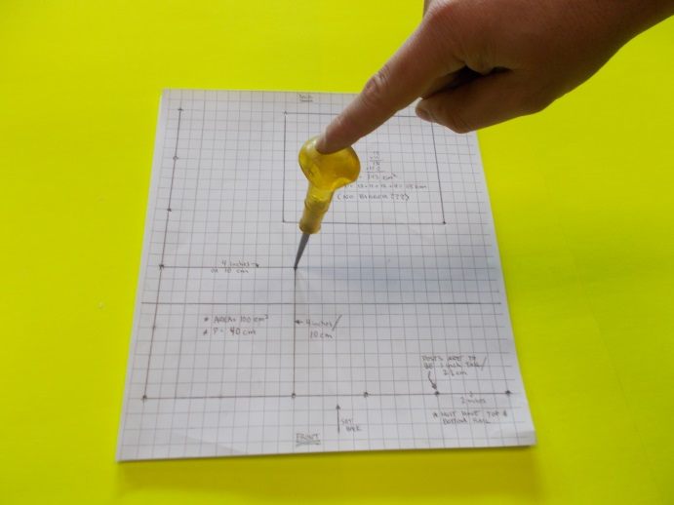
Figure 11: Using awl to transfer house location through layout grid paper.

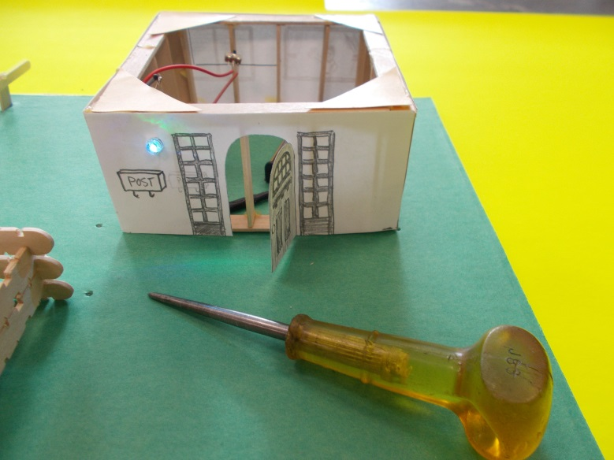
Figure 12: Use dimples in paper to locate house and garden.

STEP 3: Layout your LANDSCAPE design.
- Begin by placing your house in its location.
- Place your garden container in its location.
- Lightly draw a line where the fence will be.
- Measure each fence line

STEP 4: Fence details
- Make fence posts from round sticks. 3 cm each.
- You will need to layout your fence posts evenly along the fence line. MEASURE!!!!
- Use the fence layout metal sheets and magnets to glue your fence together.
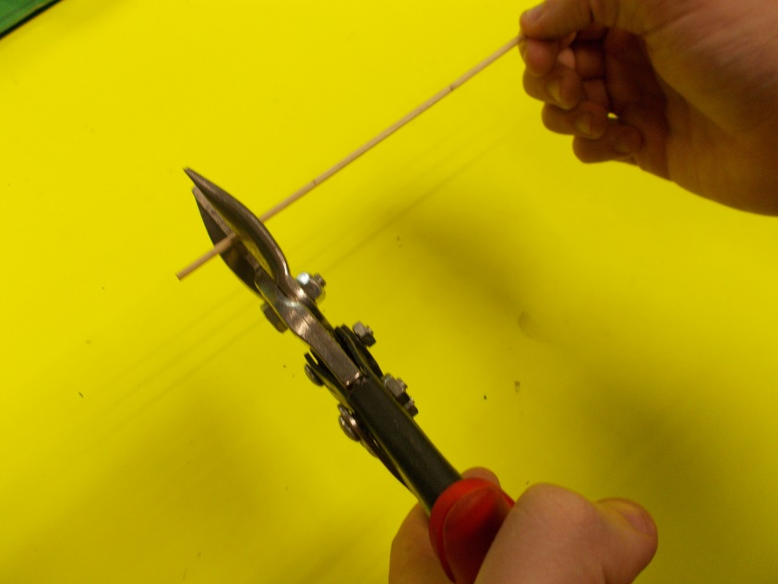
Figure 13: Use snips to cut fence posts. 3cm long.
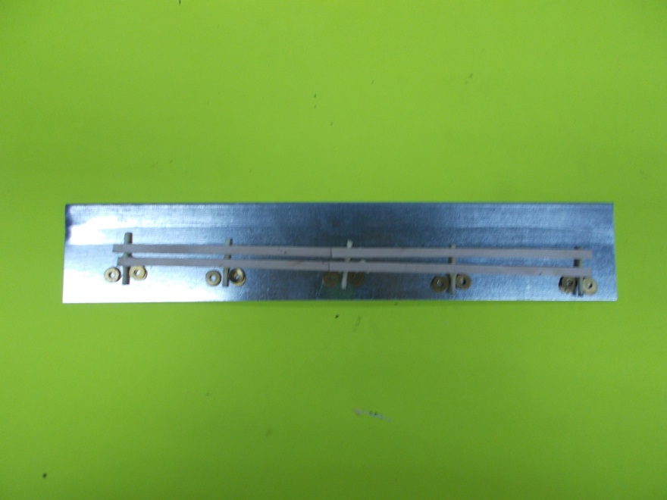
Figure 14: Use fence assembly plate and magnets to assemble fence.

STEP 5: Install fence
- Hold your fence on top of your lightly drawn fence line
- Use a pencil to mark where your fence posts will go.
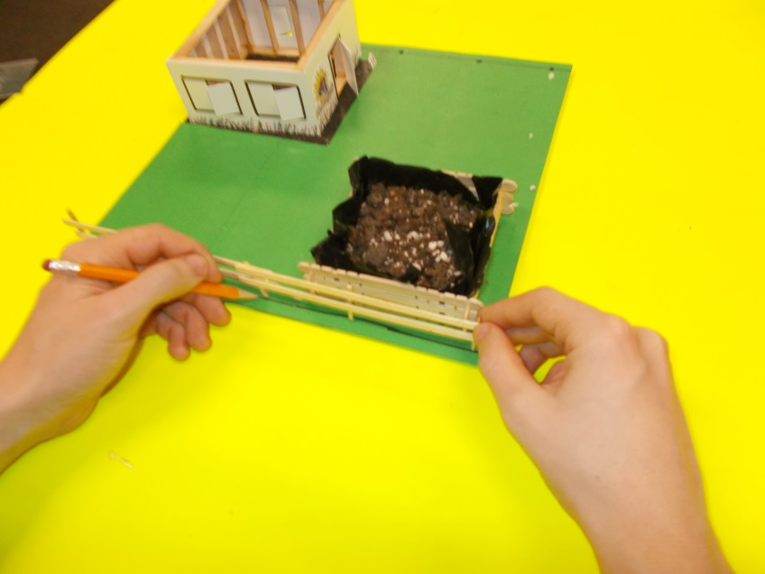
Figure 15: Laying out for fence.

- Use an awl to push through the coroplast to make a hole for the fence post.
HINT: PLACE WOOD UNDERNEATH SO YOU DON’T DAMAGE YOUR DESK!!
SAFETY: DO NOT PUT YOUR HAND WHERE THE AWL IS GOING TO POKE THROUGH!!

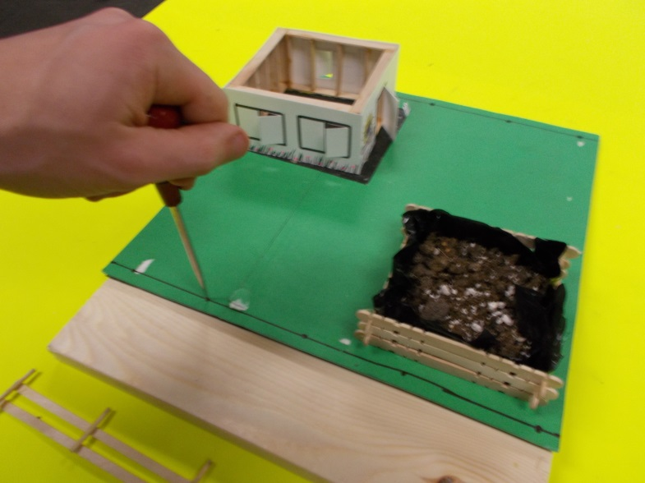
Figure 16: Using awl to "dig" fence post holes. Be careful!

- Install your fence!

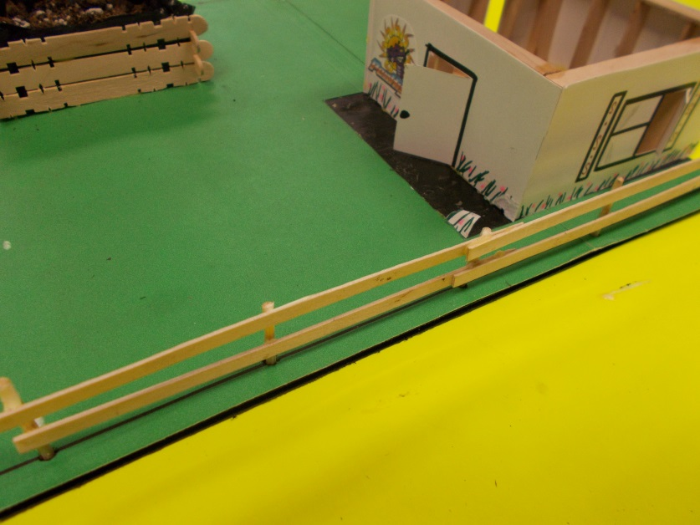
Figure 17: Fence installed!

PHASE FIVE: ELECTRICITY
Electricity is an integral part of the construction of homes. Although some homes are “off the grid” in terms of relying on a traditional supply of electricity, most homes require an electrician to safely supply electricity to your house.
STEP 1: Putting your electrical circuit together.
You will need:
-pencil - glue stick - awl - complete electrical circuit (see your teacher) -three AAA batteries

- Assemble your electrical circuit.
- Install batteries
- Test your circuit by turning it to the on position with switch.
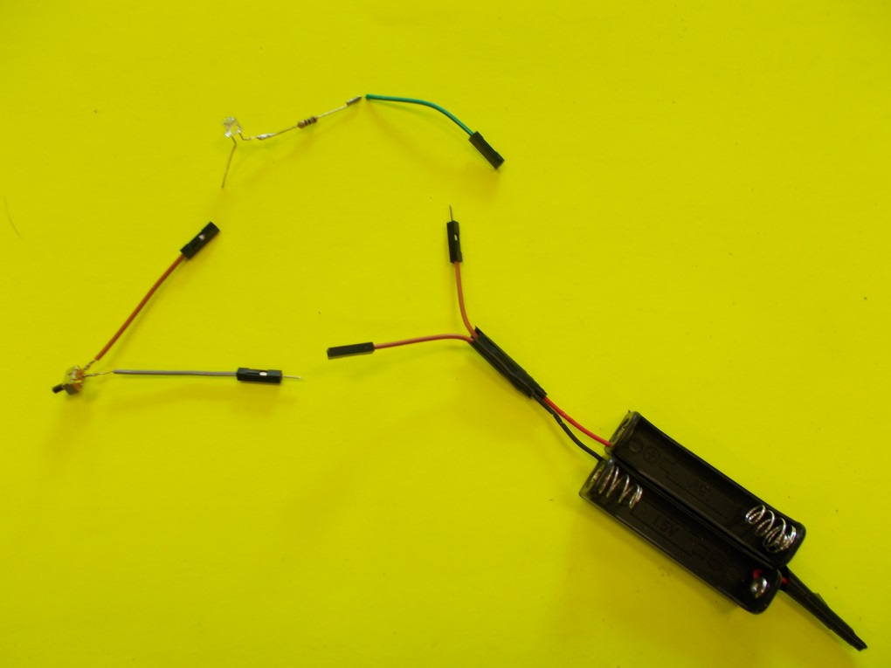
Figure 18: Electrical components.
- Decide where you would like your LED light to be located. Make a plan where you would like the switch, battery, and LED light to be located. Use glue to locate components.
YOU DECIDE!!! HAVE FUN!!! MAKE IT LOOK GOOD!!!

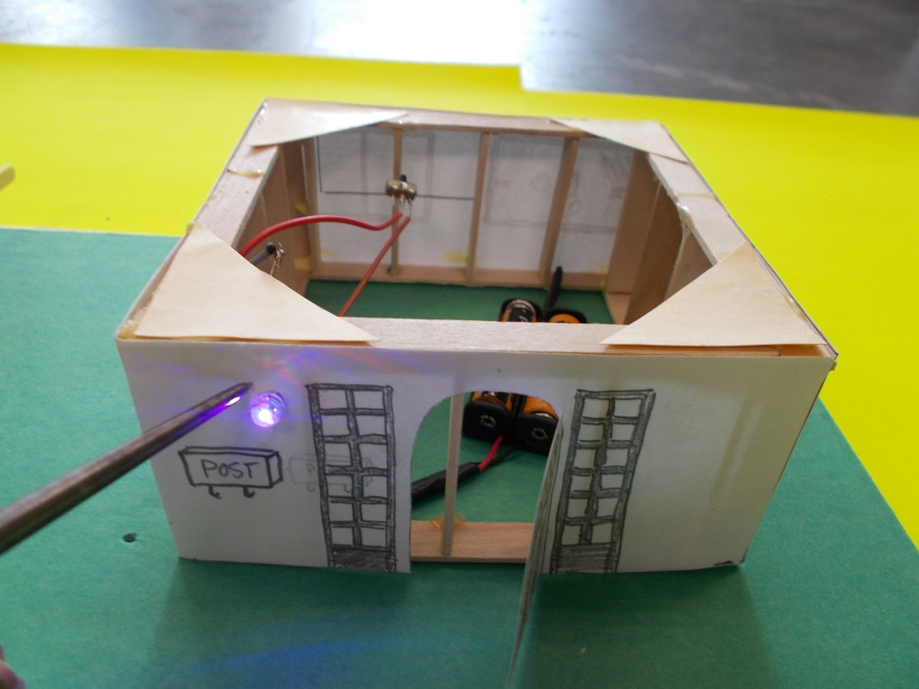
Figure 19: This light is located at the front door.

PHASE SIX: PLANTING GARDEN
Your garden will grow bean sprouts. The green roof will grow lawn. Fill both your garden container and green roof with 2 cm of potting soil. Bean sprouts and lawn seed will require two different methods of growing.
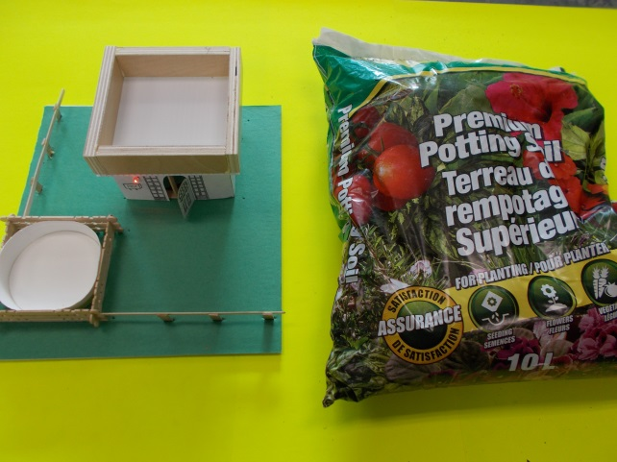
Figure 20: Potting soil ready to be installed.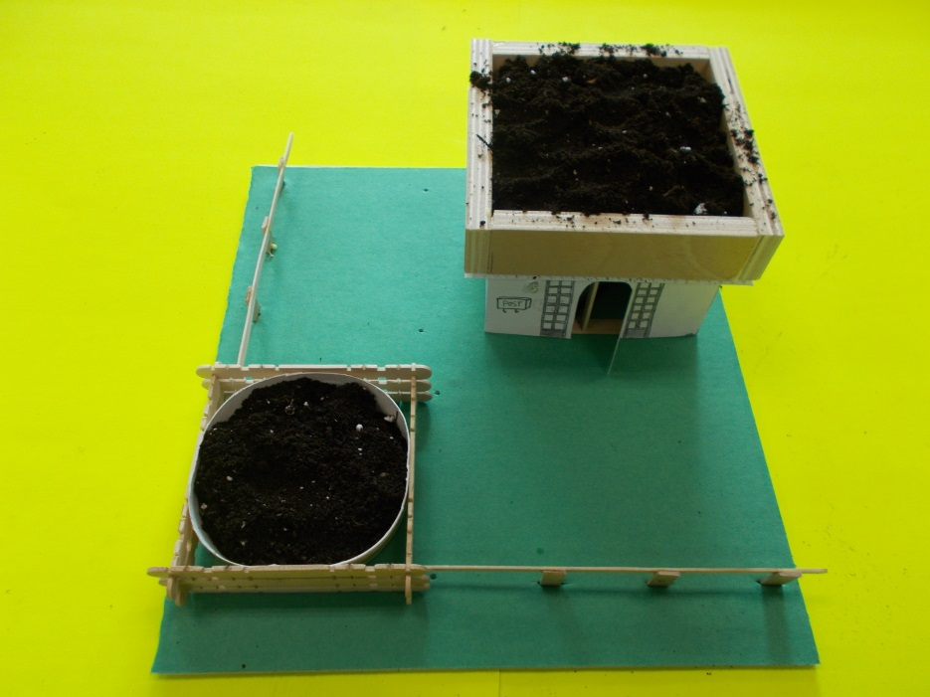
Figure 21: Potting soil installed. Ready to plant!!!!
GROWING INSTRUCTIONS
BEAN SPROUTS
STEP 1: Soak your seeds in water overnight.
STEP 2: Dampen soil with water. Remember you only need a bout 2cm of soil!
STEP 3: Evenly spread seeds across the top of the soil. You don’t need to bury the seeds.
STEP 4: Cover the garden with something to block the seeds form getting light. They need to be covered for 48 hours (or so).
STEP 5: Uncover your seeds after 48 hours. The seeds should have roots now!
STEP 6: Water!
STEP 7: You can harvest your garden after about 7 days. Yummy bean sprouts.

GREEN ROOF
STEP 1: Dampen soil with some water
STEP 2: Add lawn seed evenly across top. How much? Maybe a tablespoon-or a teeny handful.
STEP 3: Lightly mix the seeds and the very top of the soil.
STEP 5: Lightly sprinkle a bit of water over the seeds.
STEP 6: Water lightly every day. Not too much water but never let the seeds completely dry out!

